**Docker Task – 02  
===============**

**1) Create a tomcat container on 8080 and deploy sample application in tomcat.**

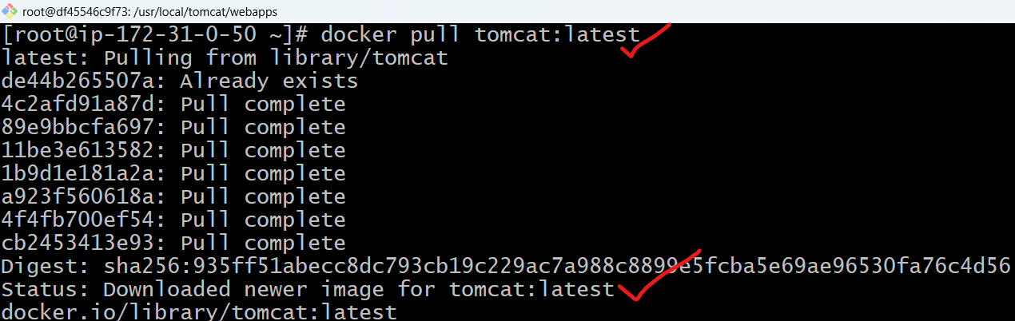

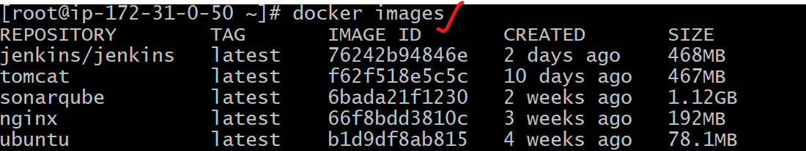

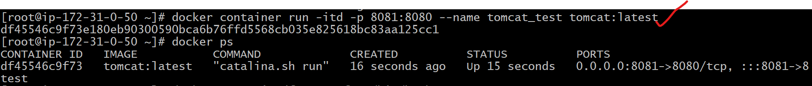

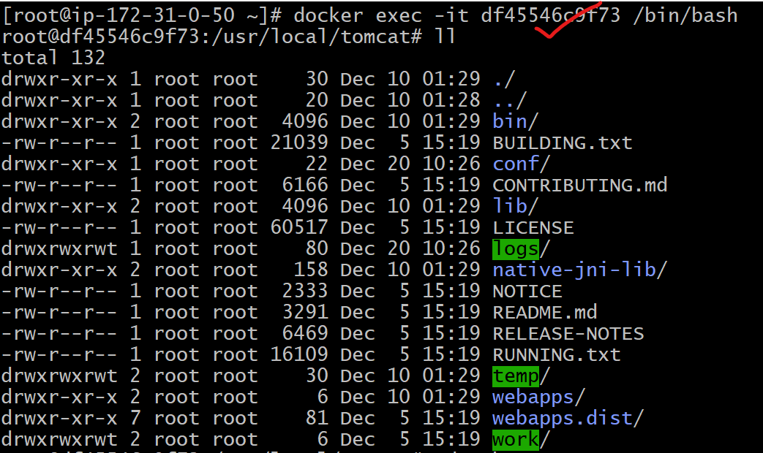

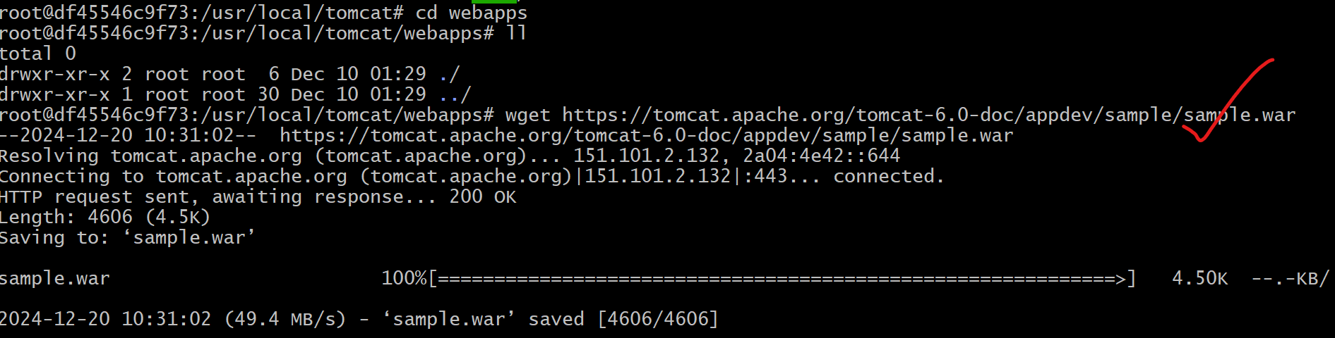

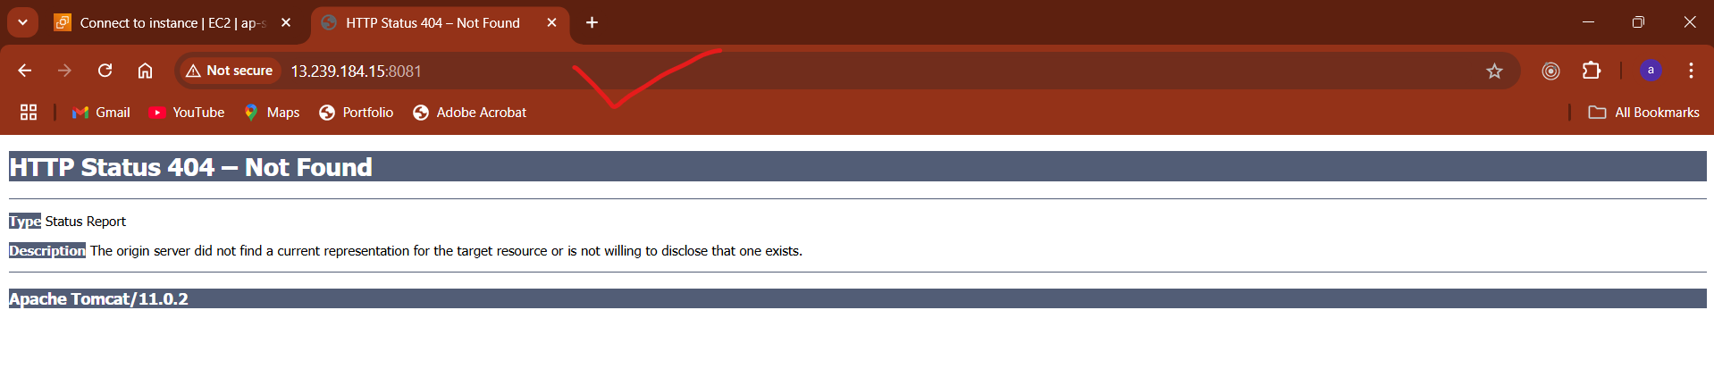

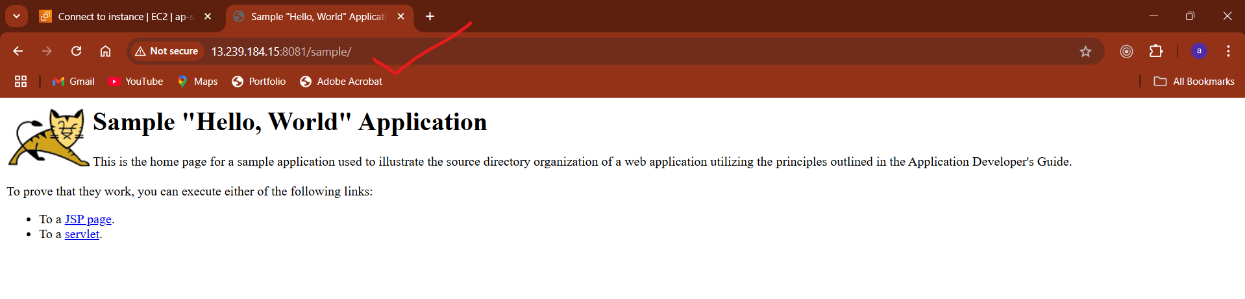

**2) Create volume and deploy tomcat container on port 8081.**

**3) Limit the nginx container to 500 MB.**

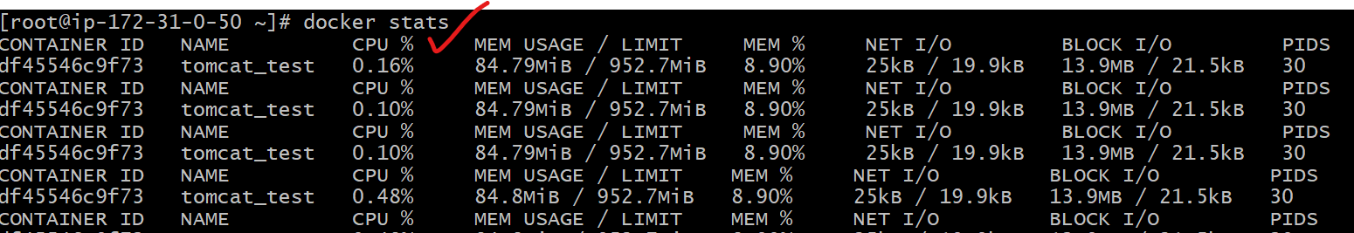



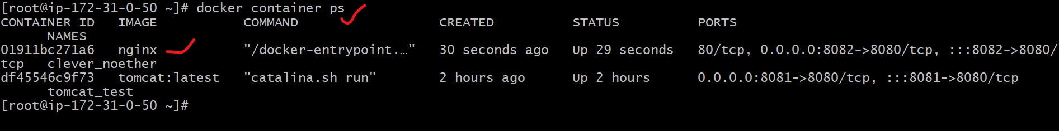

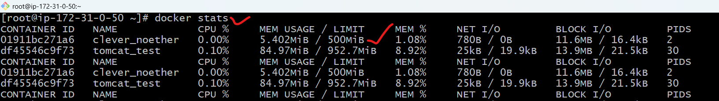

**4) Create a sample docker file using below instructions.**

**1) Base module as amazonlinux:latest**

**2) Maintainer you name**

**3) Install nginx**

**4) COPY one index.html file to image**

**5) EXpose on port 80**

**6) Command to start the nginx container**



**5) Push image to dockerhub**

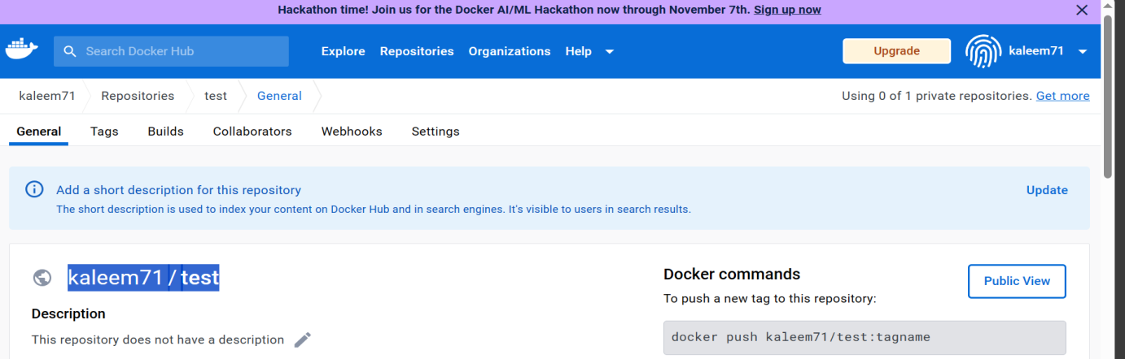

**6) push image to aws ecr**



